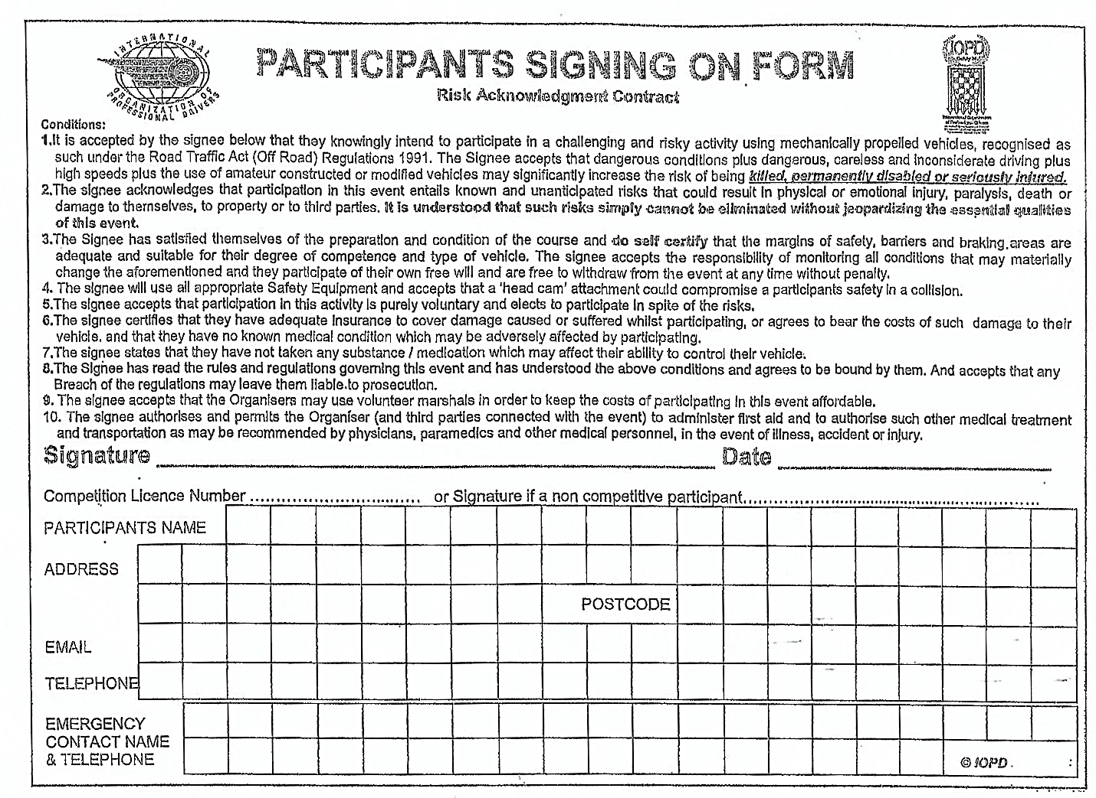

I hereby declare that myself or anyone in my household have not got or suffered from any symptoms of Covid-19 within the last 2 weeks. If I develop any symptoms within the next 14 days after my visit to the venue, I will inform EnduRocks Events team immediately.

Print: Signature:
Date:

Thank you for you understanding and patience at this very strange time. We hope you all have a safe and enjoyable days riding and please fill this form in prior to arrival at the venue and bring to the signing on point.
The EnduRocks Team

